PIZZA SALES SQL QUERIES

KPI Requirements

1.TOTAL REVENUE

SELECT SUM(total_price) AS Toatal_Revenue FROM pizza_sales

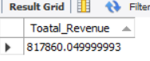

2.AVERAGE ORDER VALUE

SELECT SUM(total_price)/COUNT(DISTINCT order_id) as average_order_value from pizza_sales

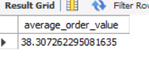

3.TOTAL PIZZA SOLD

select sum(quantity) as total_no_of_pizza_sold from pizza_sales

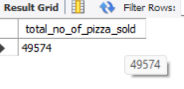

4.TOTAL ORDERS

select COUNT(DISTINCT order_id) as total_orders from pizza_sales

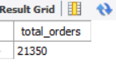

4.AVERAGE PIZZA PER ORDER

SELECT CAST(SUM(quantity) / COUNT(DISTINCT order_id) AS DECIMAL(10,2)) from pizza_sales

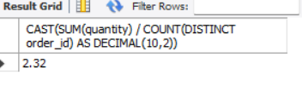

CHARTS REQUIREMENT

5.DAILY TREND FOR TOTAL ORDERS

SELECT DAYNAME(order_date) as day,COUNT(DISTINCT order_id) as no_of_orders FROM pizza_sales GROUP BY DAYNAME(order_date) ORDER BY no_of_orders

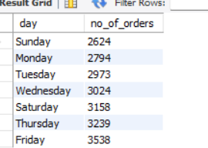

6.MONTHLY TREND FOR TOTAL ORDERS

SELECT MONTHNAME(order_date) as monthwise,Count(distinct order_id) as no_of_orders from pizza_sales GROUP BY MONTHNAME(order_date)

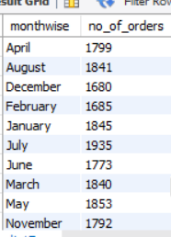

7.PERCENTAGE OF SALES BY PIZZA CATEGORY

select pizza_category,sum(total_price) as sales ,sum(total_price)*100/(select sum(total_price) from pizza_sales ) as percent_sales from pizza_sales group by pizza_category

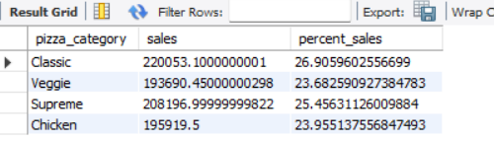

8.PERCENTAGE OF SALES BY PIZZA Size

select pizza_size,SUM(total_price)*100/(select SUM(total_price) from pizza_sales) as percent_sales from pizza_sales group by pizza_size

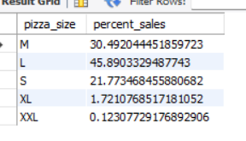

9.TOTAL PIZZA SOLD BY PIZZA CATEGORY

SELECT pizza_category,sum(quantity) pizza_sold from pizza_sales group by pizza_category

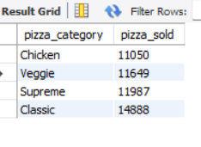

10.FIVE BESTSELLING PIZZA BY TOTAL QUANTITY

select pizza_name,sum(quantity) from pizza_sales group by pizza_name order by sum(quantity) desc limit 5

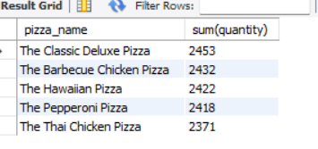

11.BOTTOM 5 BESTSELLING PIZZA BY TOTAL QUANTITY

select pizza_name,sum(quantity) from pizza_sales group by pizza_name order by sum(quantity) asc limit 5

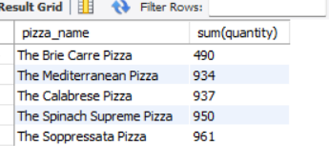

12.TOP 5 BESTSELLING PIZZA BY REVENUE

select pizza_name,sum(total_price) from pizza_sales group by pizza_name order by sum(total_price) desc limit 5

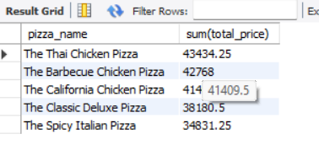

13.BOTTOM 5 BESTSELLING PIZZA BY REVENUE

select pizza_name,sum(total_price) from pizza_sales group by pizza_name order by sum(total_price) ASC limit 5

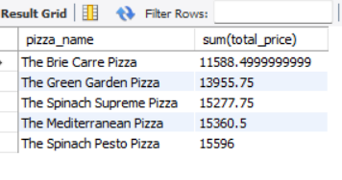

14.TOP 5 BEST SELLING PIZZA BY NO OF ORDERS

select pizza_name,COUNT(DISTINCT order_id) from pizza_sales group by pizza_name order by COUNT(DISTINCT order_id) DESC limit 5

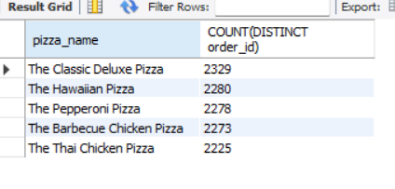

15.BOTTOM 5 BEST SELLING PIZZA BY NO OF ORDERS

select pizza_name,COUNT(DISTINCT order_id) from pizza_sales group by pizza_name order by COUNT(DISTINCT order_id) ASC limit 5

